**Worksheet – 2.3**

**Student Name:** Vivek Kumar  **UID:** 21BCS8129

**Branch:** BE-CSE (LEET) **Section/Group:** 809/A

**Semester:** 4th **Date of Performance:** 15/04/2022

**Subject Name:** Computer Network Lab **Subject Code:** 20CSP-257

**1. Aim/Overview of the practical:**

Create a network to implement Distance Vector routing Protocol using Packet Tracer (STATIC).

**2. Task to be done/ Which logistics used:**

Distance Vector routing Protocol using Packet Tracer (STATIC).

**Prerequisites:**

**S/W:**

* Laptop/Desktop
* CISCO Packet Tracer program

**H/W:**

* Main Memory - 128 MB RAM
* Hard Disk – minimum 20 GB IDE Hard Disk
* 44 MB Floppy Disk Drive
* –52X IDE CD-ROM Drive
* PS/2 HCL

**3. Steps for experiment/Code with Result/Output:**

Theory: In computer communication theory relating to packet-switched networks, a distance-vector routing protocol is one of the two major classes of routing protocols, the other major class being the link-state protocol. Distance-vector routing protocols use the Bellman–Ford algorithm, Ford–Fulkerson algorithm, or DUAL FSM (in the case of Cisco System’s protocols) to calculate paths. A distance-vector routing protocol requires that a router informs its neighbors of topology changes periodically. Compared to link-state protocols, which require a router to inform all the nodes in a network of topology changes, distance-vector routing protocols have less computational complexity and message overhead.

**Procedure:**

Create the network using 3 router which contains serial port in it.

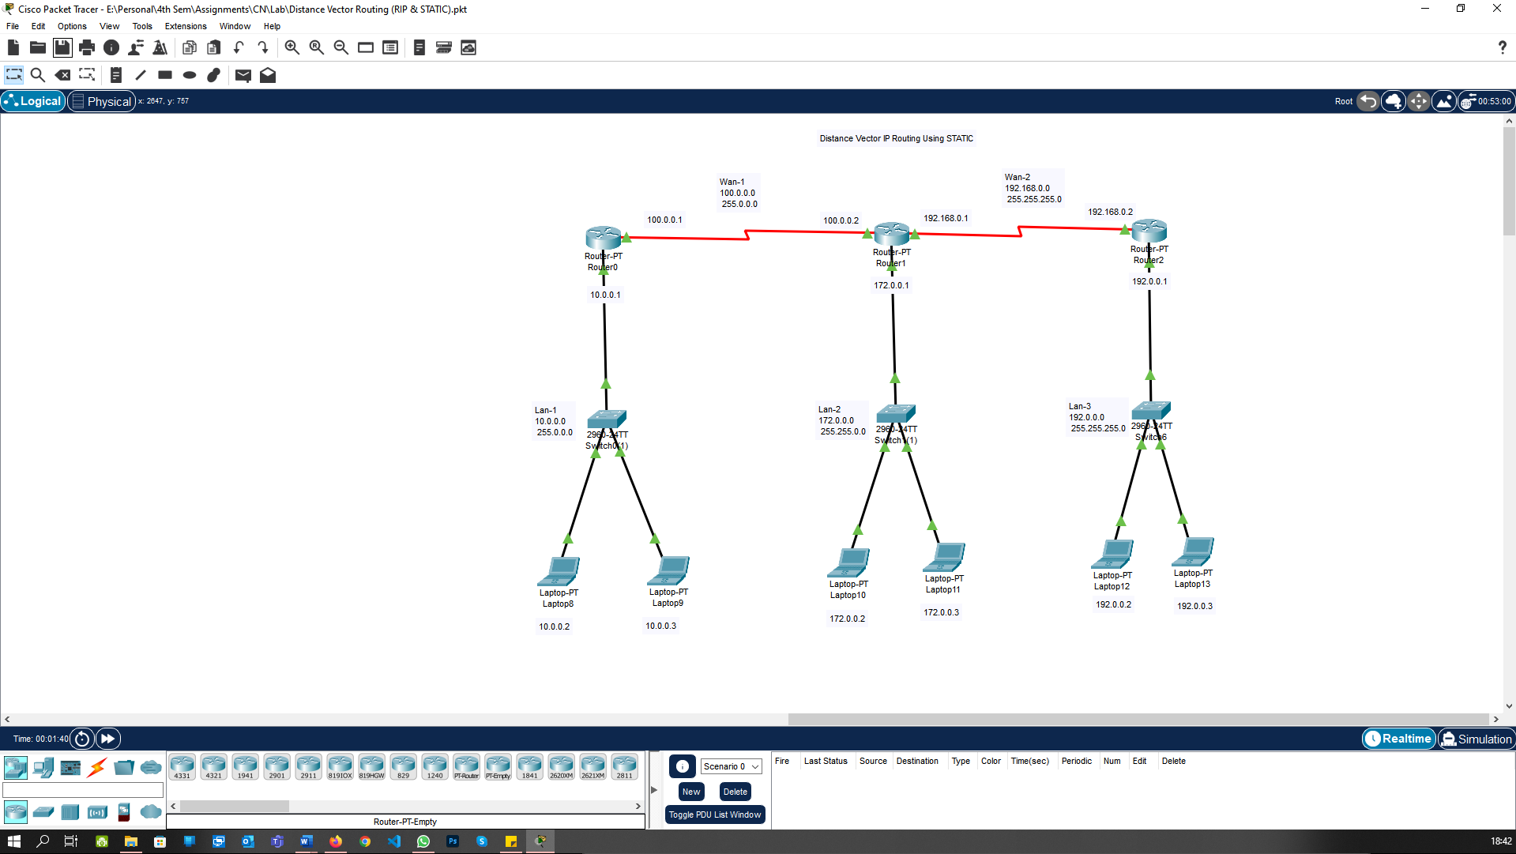

Assign the IP address for all PC and Router connected to the Switch 3.

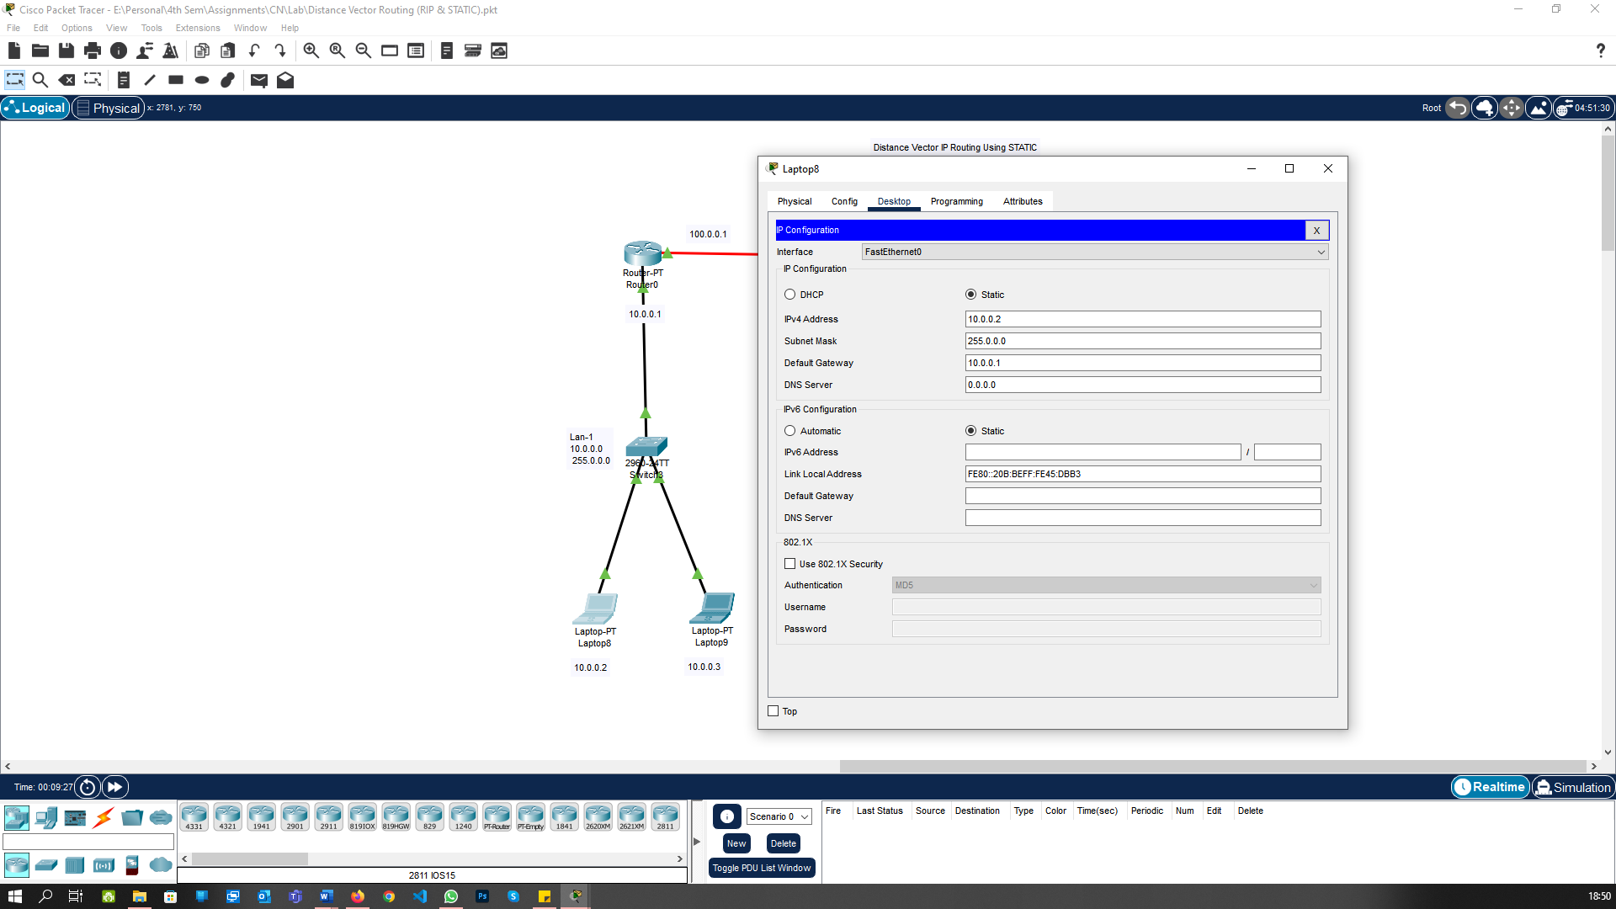

Assign the IP address for Router 0.

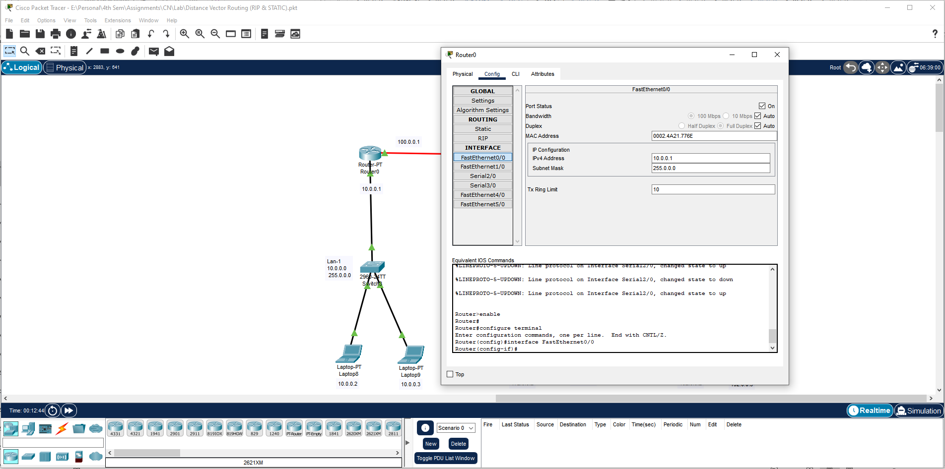

Assign the IP address for all PC and Router connected to the Switch 4.

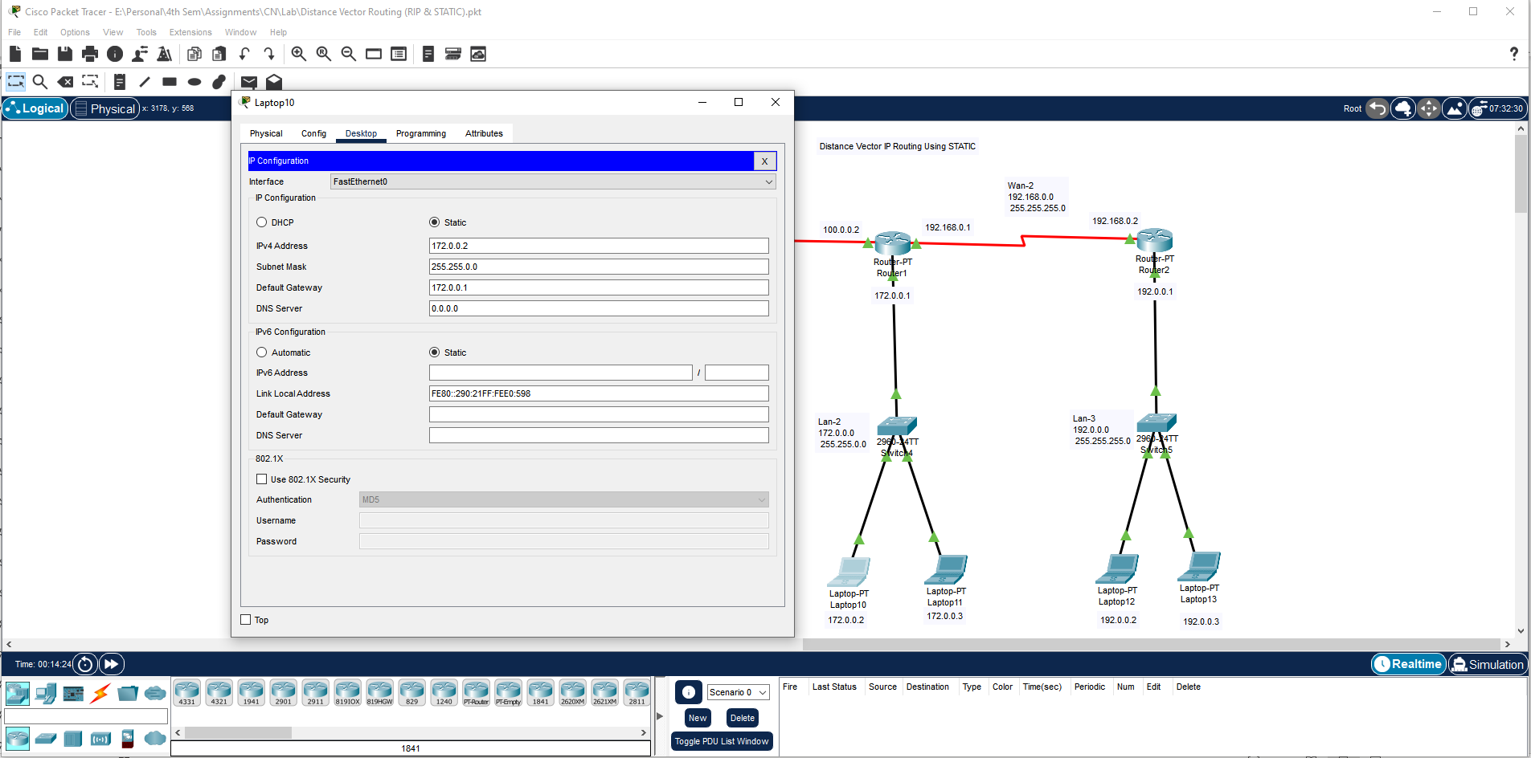

Assign the IP address for Router 1.

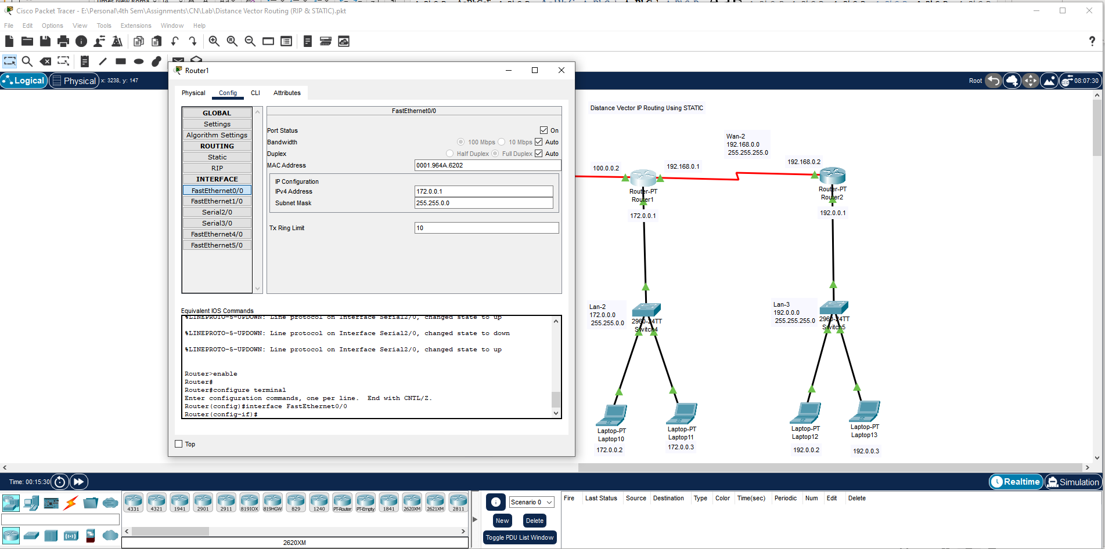

Assign the IP address for all PC and Router connected to the Switch 4.

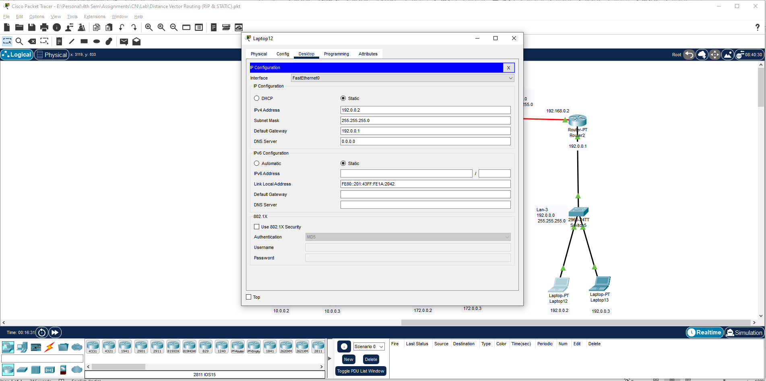

Assign the IP address for Router 2.

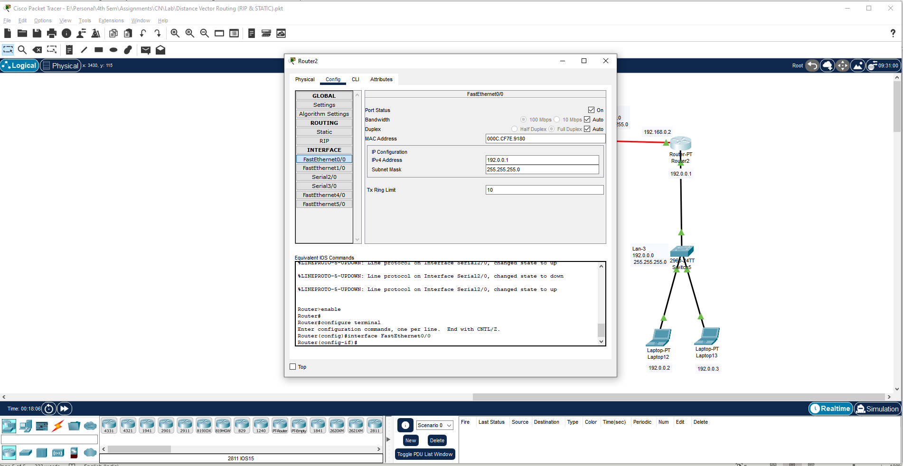

Assign the IP address for Serial Ports of Router 2.

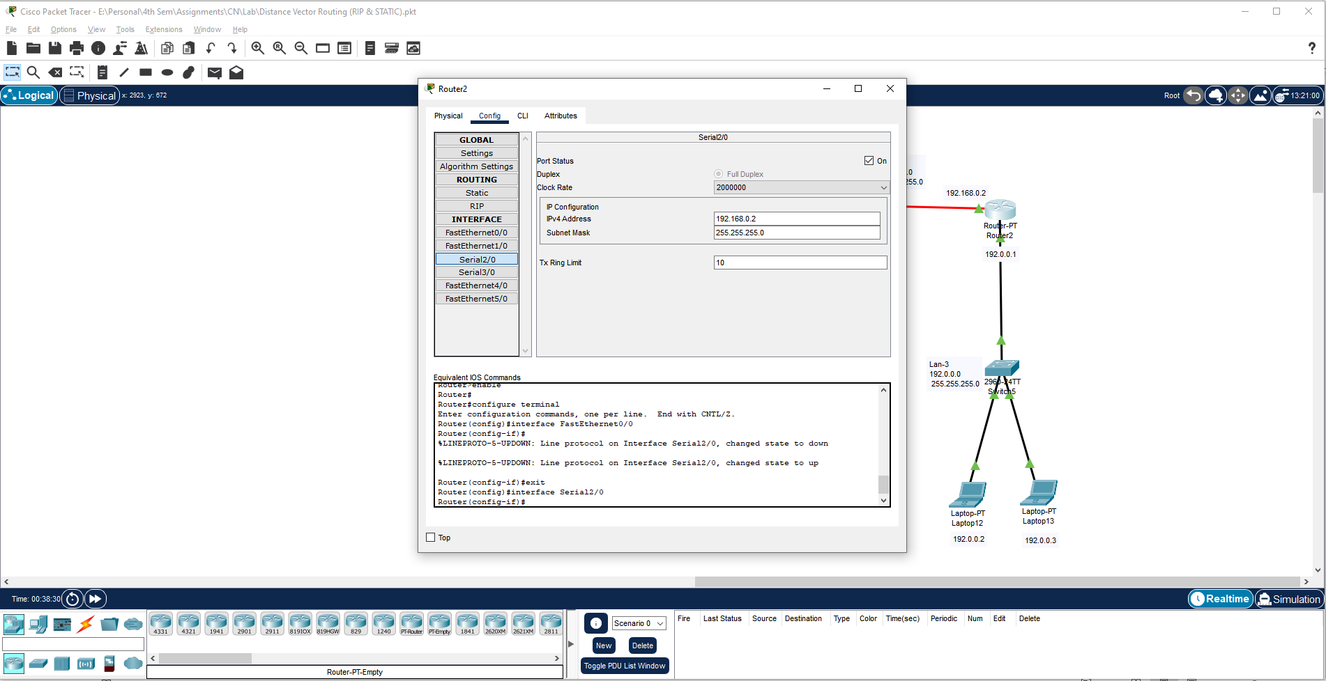

Assign the IP address for Serial Ports of Router 1.

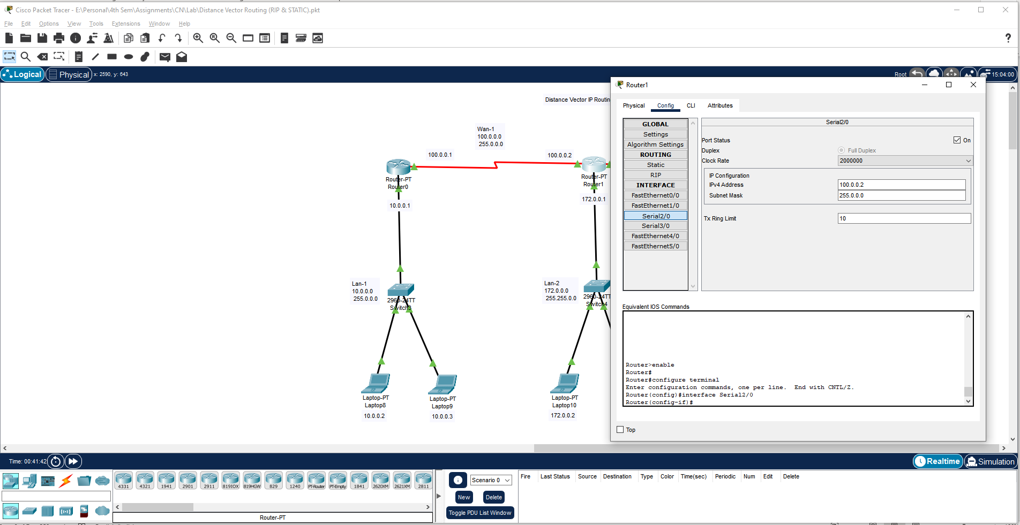

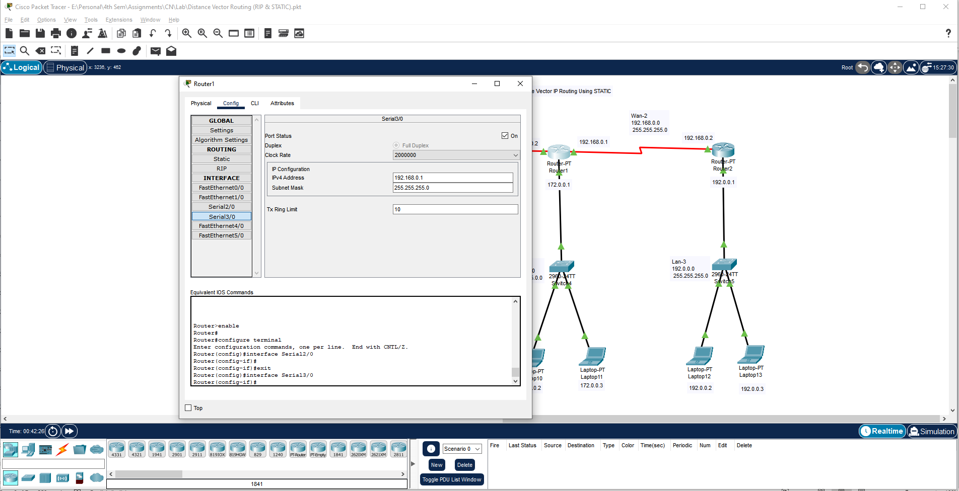

Assign the IP address for Serial Ports of Router 0.

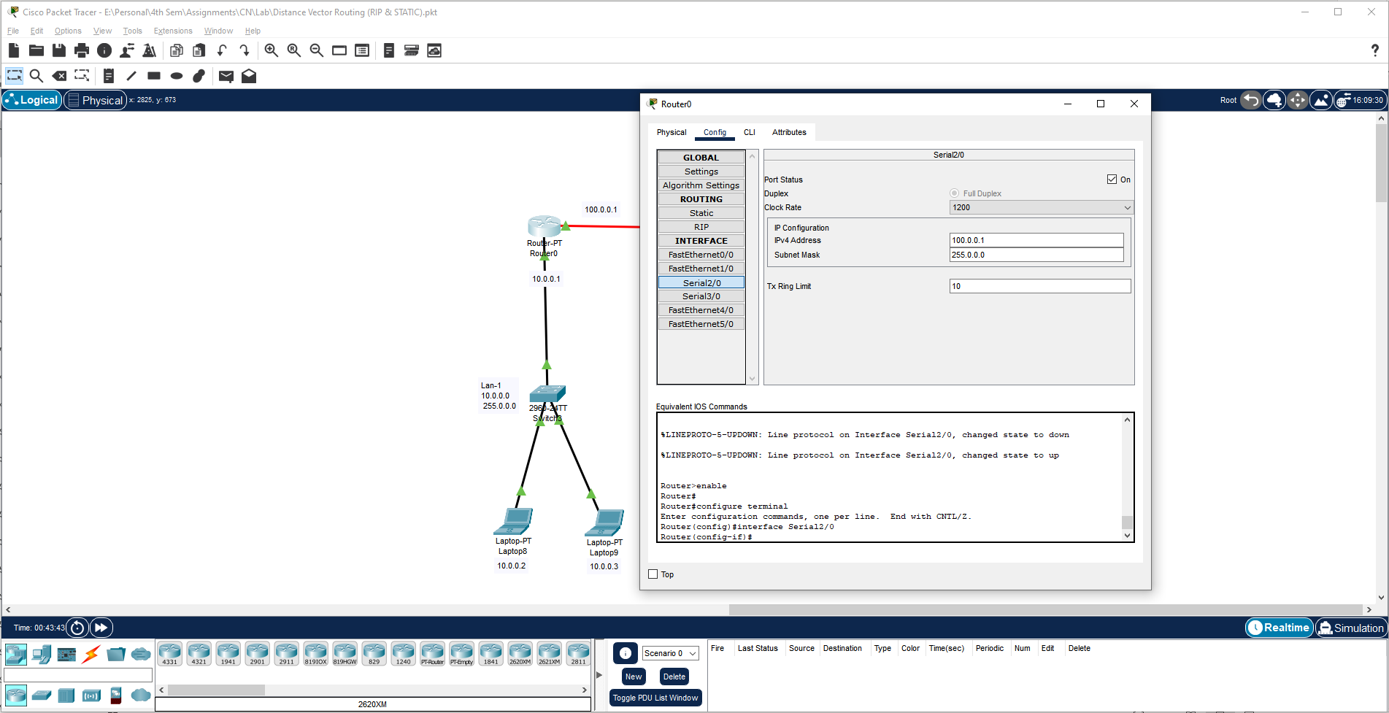

Add the Static Routes in Router 0.

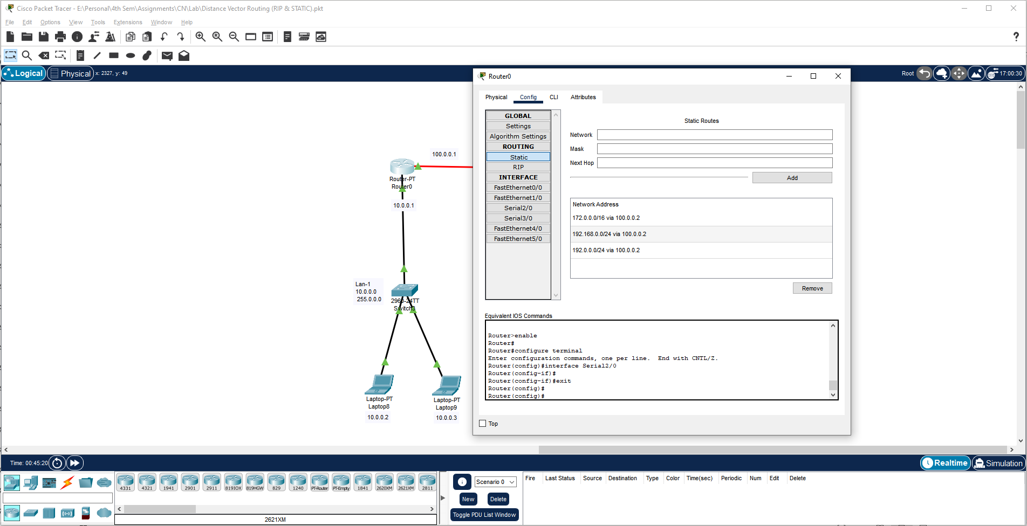

Add the Static Routes in Router 1.

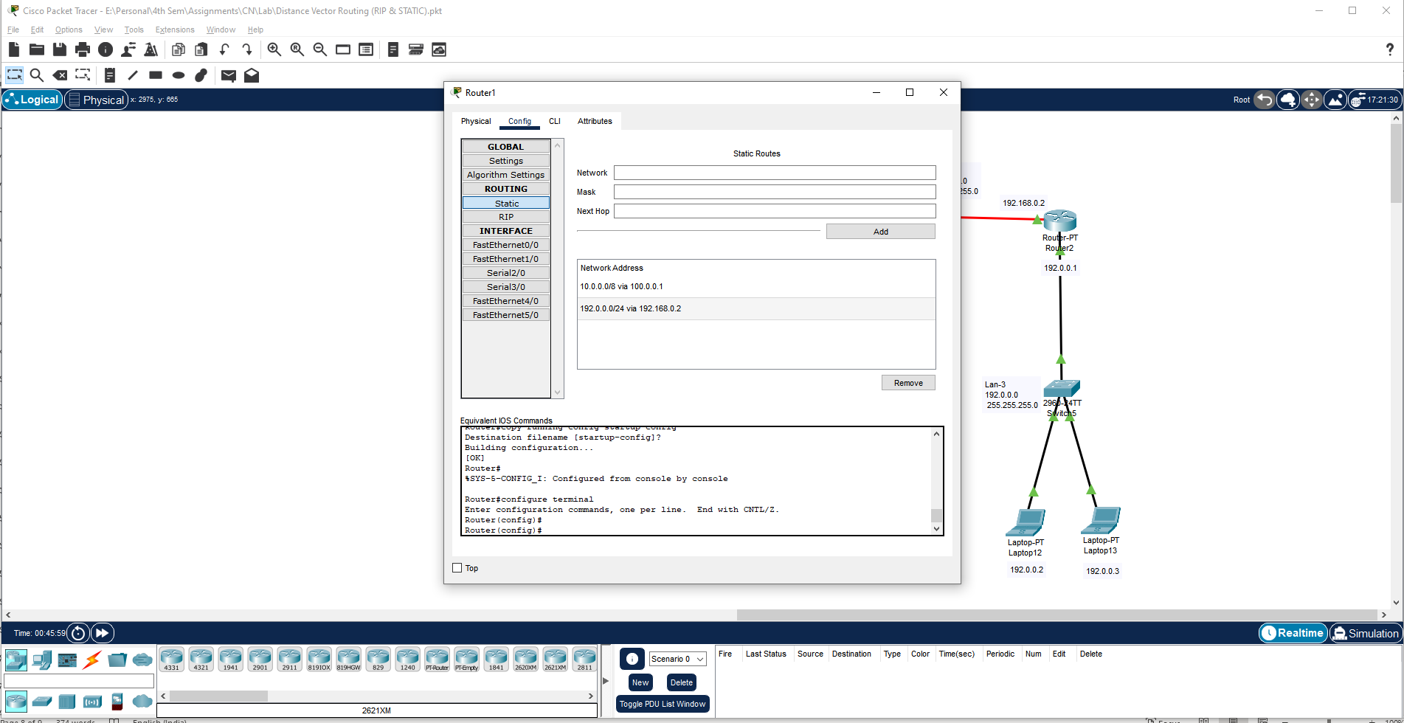

Add the Static Routes in Router 2.

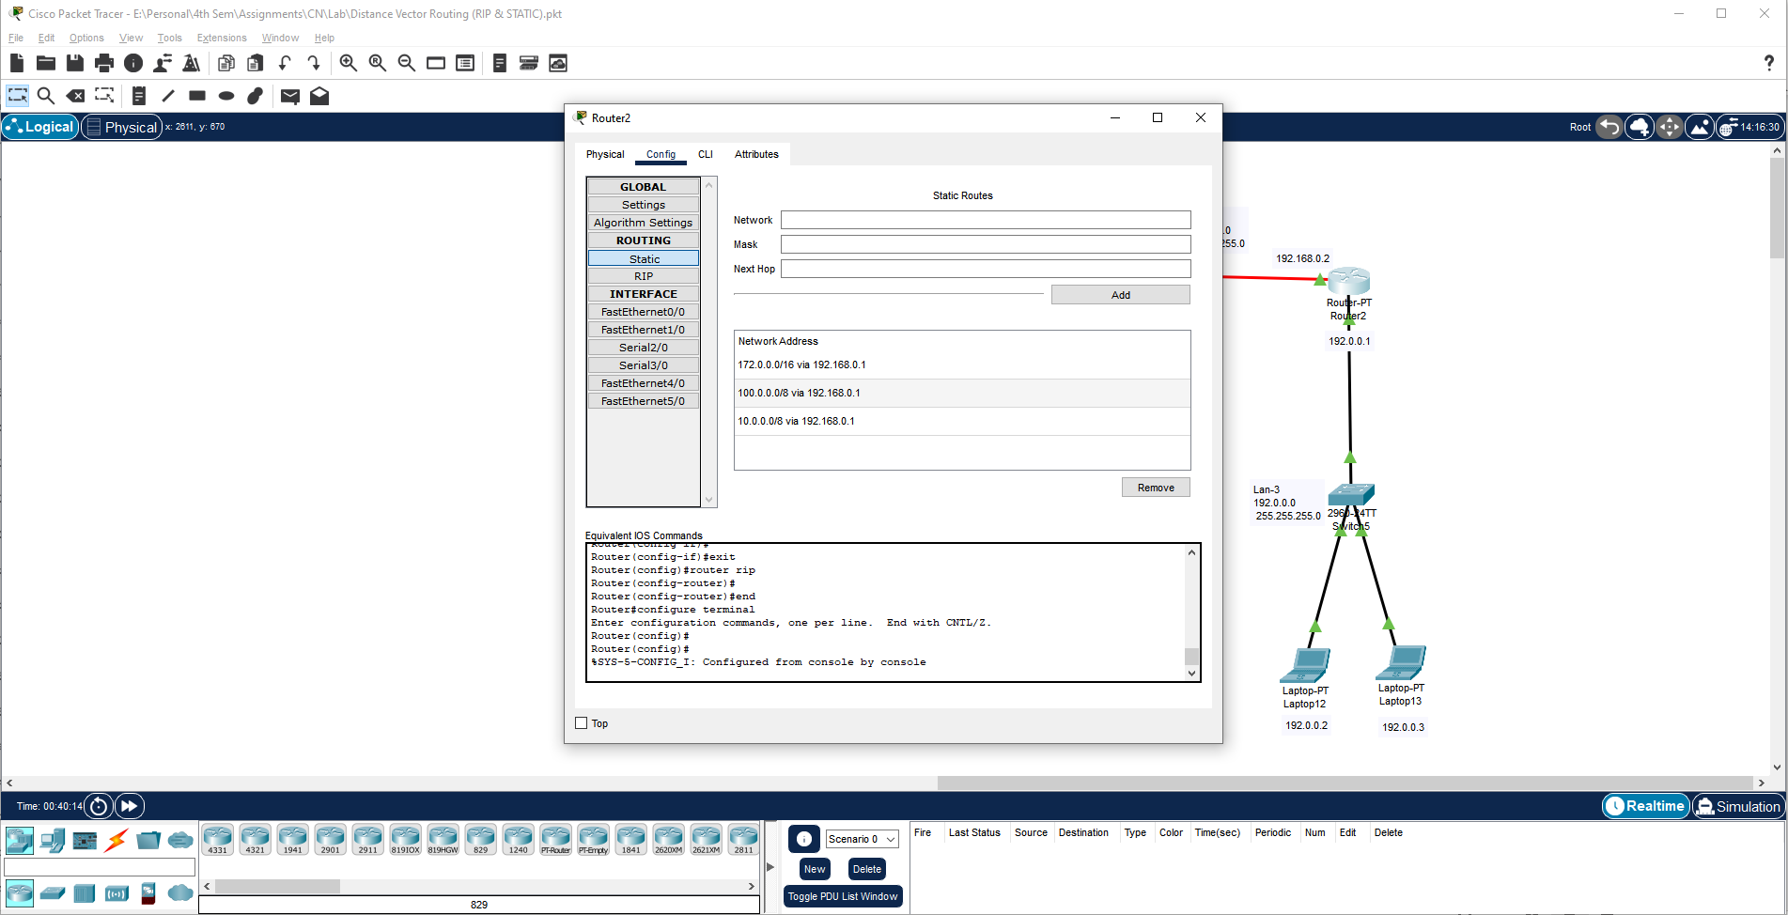

Send the Message in Realtime and Check the Connectivity.

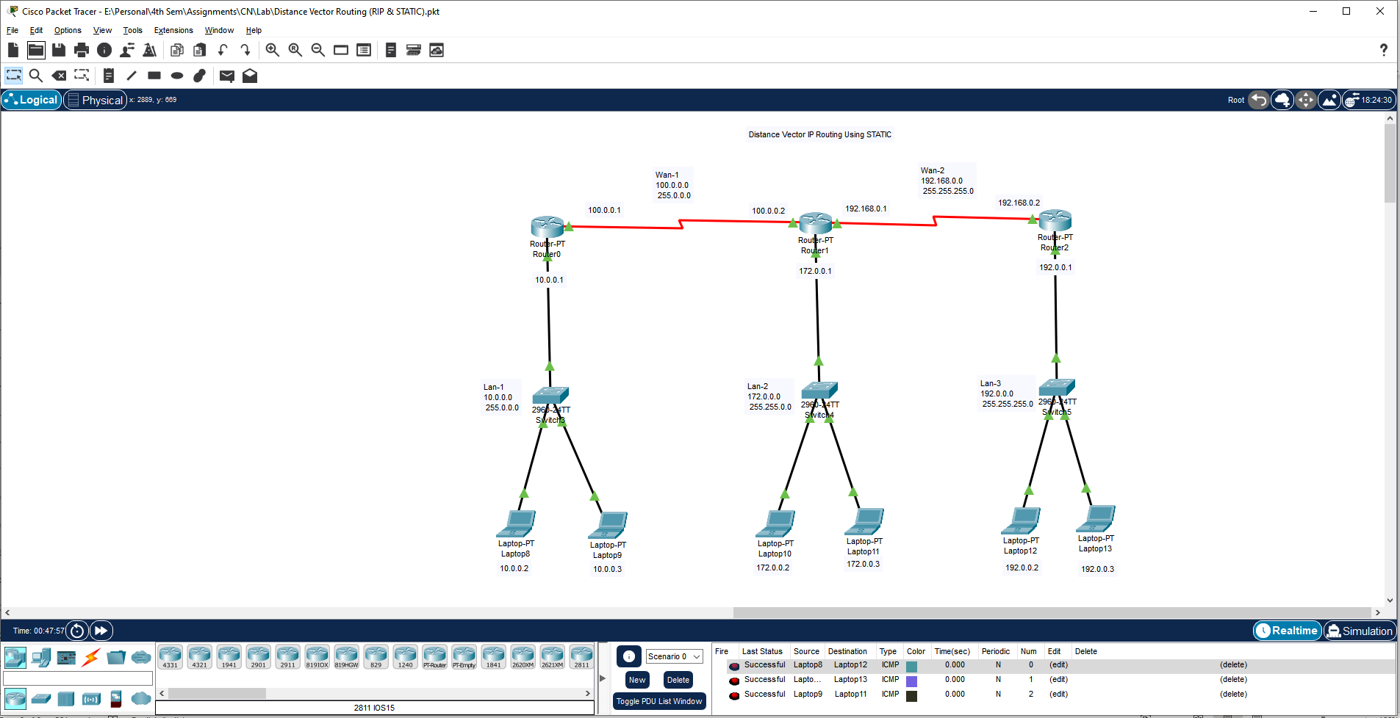

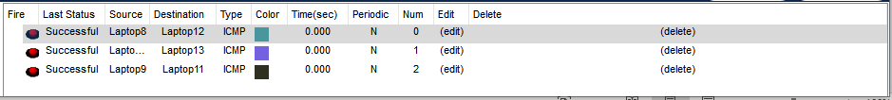

Send the Message in Simulation and See the Steps.

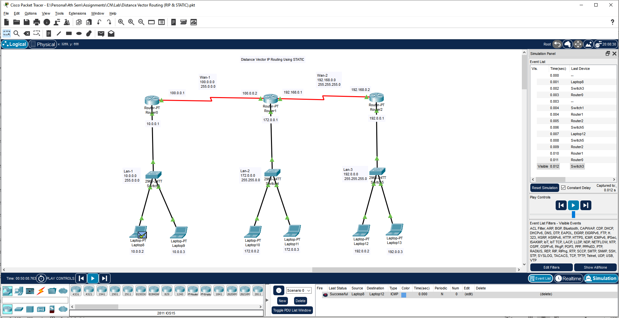

**Learning outcomes (What I have learnt):**

**1.** Understand working of network device Network Topologies.

**2.** Create and Executed all Network Topologies using switch.

**Evaluation Grid (To be created as per the SOP and Assessment guidelines by the faculty):**

|  |  |  |  |
| --- | --- | --- | --- |
| Sr. No. | Parameters | Marks Obtained | Maximum Marks |
| 1. |  |  |  |
| 2. |  |  |  |
| 3. |  |  |  |
|  |  |  |  |